Supplementary material

Feature distance of image patches for tracklet merging
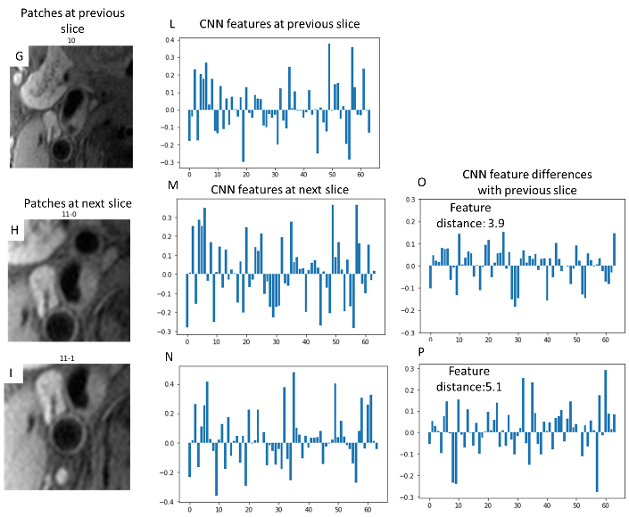
Fig. 1 CNN feature and feature distances for patches from Figure 3 in the main manuscript. L, M, N are the 64-dimensional features for the patches shown in G, H, I. O and P are the feature distance between L vs M and L vs N. Tracklets are merged with smaller feature distance. In this case, L is merged with M.

Polar conversion
The polar image patches $P[t,r]$ with the size of $4h*4w$ are converted from cartesian image patches $\hat{P}[y,x]$, using the polar transformation relation of $P\left[t,r\right]=f\left(\hat{P}\left[y,x\right]\right)$
$$\left\{\begin{matrix}r=\sqrt{{(y-2*h)}^{2}+{(x-2*w)}^{2}} \\ t=\left\{\begin{aligned}\begin{aligned}\frac{h}{180}\arctan\left(\frac{y-2*h}{x-2*w}\right), y>2*h and x>2*w \\ \frac{h}{180}\arctan\left(\frac{y-2*h}{x-2*w}\right)+180, y<2*h \\ \frac{h}{180}\arctan\left(\frac{y-2*h}{x-2*w}\right)+360, y>2*h and x<2*w\end{aligned} \\ 90, x=2*w and y=2*h+r \\ 270, x=2*w and y=2*h-r\end{aligned}\right.\end{matrix}\right.$$
The inverse polar conversion for patches is defined as $\hat{P}\left[y,x\right]=f^{-1}\left(P\left[t,r\right]\right)$, where
$$\left\{\begin{matrix}y=2*h+r*\sin\left(t*\frac{360}{2*h}\right) \\ x=2*w+r*\cos\left(t*\frac{360}{2*h}\right)\end{matrix}.\right.$$

Upper limit of polar regression
Upper limit of vessel wall segmentation through polar regression is shown in Table 1. We observe that once the number of directions is beyond 64, there is little difference in terms of DSC with ground truth. The high DSC (>0.96) indicates the feasibility of using polar regression on vessel wall segmentation without much deterioration of labels. So the number of 256 directions is used, which is the same as the largest value in $r$ axis to maintain the square shape of polar patches. Compared with the upper limit, our best polar regression model still has much room for improvement, so the loss of accuracy in the polar conversion is not our top concern for now.
Table 1 Upper limit of vessel wall segmentation through polar regression
Number of directions | Mean DSC | Percent of DSC<0.93 | Percent of DSC<0.95
32 | 0.9597 | 1.54% | 20.20%
64 | 0.9623 | 0.44% | 14.18%
128 | 0.9630 | 0.24% | 12.91%
256 | 0.9626 | 0.50% | 14.06%
512 | 0.9618 | 0.56% | 15.36%

Evaluation metrics
Dice similarity coefficient (DSC) [1] is defined as
$$DSC= \frac{2(A∩B)}{A+B}$$
where A is the ground truth result and B is the segmentation result. DSC ranges from 0 (no overlap) to 1 (identical results). DSC > 0.7 indicates excellent agreement [1].
Degree of similarity (DoS) [2] is defined as
$$DoS=\frac{\sum_{n=0}^{N}{p_{n}(d)}}{N} where p_{n}\left(d\right)=\left\{\begin{aligned}1, if d≤T \\ 0, if d>T\end{aligned}\right.$$
N is the number of paired sample points on the predicted contour and the ground truth contour, $N$ = 100 is used in literature and in this study. Each pair of points on the contours have a distance of $d$. $T$ is a distance threshold to allow the errors of contour prediction, which is chosen as the same as the imaging resolution as the common practice.
Dataset detailed property
TABLE 2
Imaging parameters and properties for datasets used in this study
 | CARE-II | Kowa
Scanned artery region | Carotid artery
Sequence | Fat suppressed T1 weighted Turbo Spin Echo
Blood suppression | Quadruple inversion recovery
Number of subjects | 954 |  | 203
Number of labeled slices | 27397 |  | 5194
TR (ms) | 800 |  | 800
TE (ms) | 10 |  | 10
In-plane Resolution (mm) | 0.57*0.57 |  | 0.63*0.63
Spacing between slices (mm) | 2 |  | 2
Field of view (mm*mm) | 160*160 |  | 160*160

Rotated patch with different gaps
Parameter $G$ used in combing patch rotation for prediction is selected based on the tradeoff between calculation time, accuracy and uncertainty scores. Lower $G$ means more overlapping rotated patches are used in segmentation, which costs more time but could generate a smoothed probability map and/or contours by averaging from different patches (glitches from a few rotated patches might be subdued). In addition, with enough samples of predictions from multiple patches, the distribution of boundary can be better reflected. On the other extreme, predicting without overlap ($G=2*h$) cannot calculate boundary consistency at all, and segmentation from a single patch may lead to rough probability map and/or boundaries. Different $G$ values are selected (from 1 to $2*h$) and evaluated from the validation set of the carotid dataset, then a best tradeoff value is used to apply to the test set. The set of DSC (vessel wall, lumen, and outer wall), DoS (lumen and wall), correlation coefficients of uncertainty scores with DSC (CC-Lumen, CC-Wall), and the calculation time is shown in Table 3.
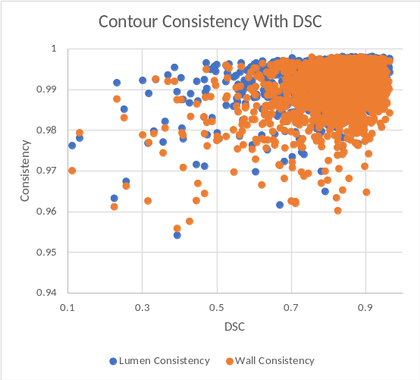
Fig. 2 Contour consistency with DSC from the Polar-Reg CNN architecture.
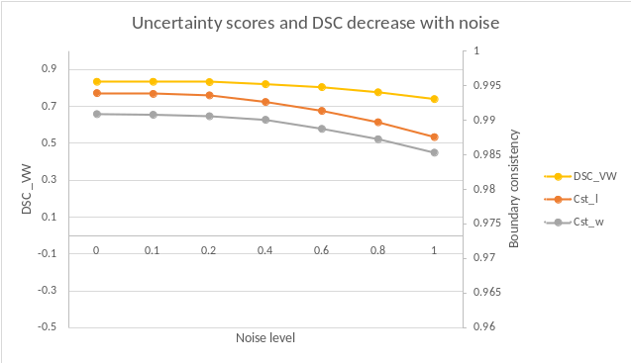
Fig. 3 Decreased DSC and uncertainty scores (Cst_l/Cst_w: boundary consistency for lumen/outer wall) with increased level of noises from the Polar-Reg CNN architecture.

Segmentation uncertainty scores
The scatter plots between lumen and wall consistency scores ${Cst}_{l,w}\left(P\right)$ with DSC^{VW} for the Polar-Reg CNN architecture is shown in Fig. 1. Generally, lower boundary consistencies indicate poor segmentations having low DSC compared with human labeled vessel wall. Lumen consistency score has the correlation coefficient of 0.132 (p<1e-5), and wall consistency score has the correlation coefficient of 0.047 (p=0.045).
To further prove the sensitivity of consistency scores when the vessel wall image is of lower quality, we added different levels of random noises following the Rayleigh distribution with mode of 1 to the existing vessel wall images. The noise added image $P^{n}\left[t,r\right]=P\left[t,r\right]+n*N\left[t,r\right]$ where $N\left[t,r\right]$ follows $r\left(x\right)=x∙exp⁡(-\frac{x^{2}}{2})$. DSC^{VW} and mean of each of three uncertainty scores are evaluated from different noise levels $n$ at [0,0.2,0.4,0.6,0.8,1]. The line plot of results is shown in Fig. 2.
Table 3 Comparison between gaps of rotated patch from the validation set
Gap | DSC^{VW} | DSC^{Inner} | DSC^{Outer} | DoS^{Lumen} | DoS^{Wall} | CC-Lumen | CC-Wall | Time (s)
1 | 0.824 | 0.945 | 0.949 | 0.856 | 0.776 | 0.449 | 0.350 | 3.06
2 | 0.824 | 0.945 | 0.949 | 0.856 | 0.776 | 0.448 | 0.350 | 1.57
5 | 0.824 | 0.945 | 0.950 | 0.856 | 0.776 | 0.448 | 0.346 | 0.68
10 | 0.824 | 0.945 | 0.950 | 0.857 | 0.776 | 0.449 | 0.343 | 0.37
20 | 0.823 | 0.945 | 0.949 | 0.857 | 0.774 | 0.436 | 0.334 | 0.22
32 | 0.823 | 0.944 | 0.949 | 0.855 | 0.774 | 0.469 | 0.384 | 0.17
64 | 0.823 | 0.944 | 0.949 | 0.854 | 0.776 | 0.411 | 0.318 | 0.12
128 | 0.823 | 0.944 | 0.949 | 0.853 | 0.778 | 0.356 | 0.206 | 0.09
256 | 0.820 | 0.943 | 0.948 | 0.851 | 0.772 | N/A | N/A | 0.08

Reference
[1] L. R. Dice, “Measures of the Amount of Ecologic Association Between Species,” Ecology, vol. 26, no. 3, pp. 297–302, Jul. 1945.
[2] E. Angelie, E. R. Oost, D. Hendriksen, B. P. F. Lelieveldt, R. J. Van der Geest, and J. H. C. Reiber, “Automated Contour Detection in Cardiac MRI Using Active Appearance Models,” Invest. Radiol., vol. 42, no. 10, pp. 697–703, 2007.

